[Date]
September 07, 2018

Skype for Business
Basics with Tips and Tricks

Table of Contents

Basics 2
Downloading Skype for Business 2
Signing-In to Skype 3
Set Up 4
Skype Status 4
Making Contact: One or More 5
Creating On-line Meetings 6
Searching for another Employee (or external client) 7
Conversation History 8
Personal Settings 9

Basics

Downloading Skype for Business

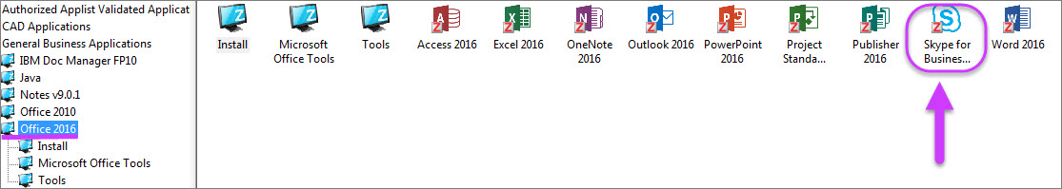
In order to install “Skype for Business” on your PC, you must first install Office 2016. Next, install “Skype” chat/instant message tool by right clicking on the “Skype” icon and clicking “Install”. After the initial install, the application icon will appear on your home page.


Signing-In to Skype

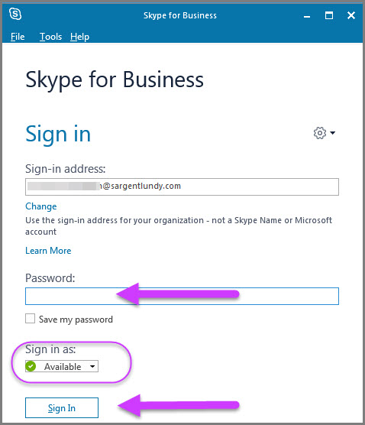
Your.name@sargentlundy.com
The application will auto launch when you log onto your computer, therefore you will need to sign-in sign-in using the same as your Sargent & Lundy E-mail and password log on.
You may adjust your status availability using the drop-down menu.
Click “Sign In”

Set Up

Skype Status
Select Status by Color
Underneath your name, click the down arrow to display a list of options on your status.
As you can see, your list of contacts, favorites or groups, will have their status.
If you have “available” and your calendar is booked, it will switch to “busy”
If you wish to remove your status click the “Sign Out” option.
If you wish to change your status either click on the new status or “Reset Status” and change the status.
To exit, click “Exit”

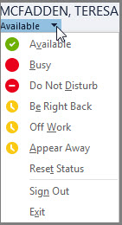
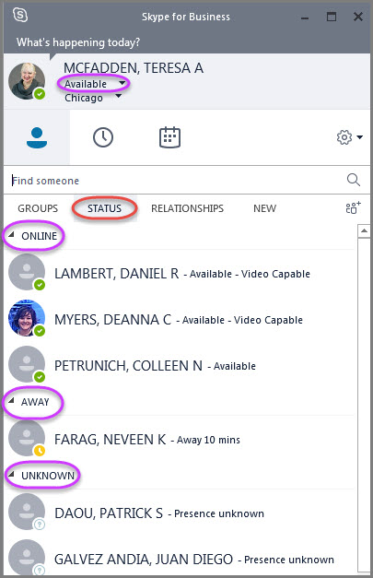

Making Contact: One or More
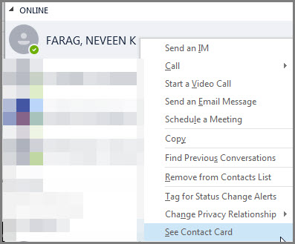
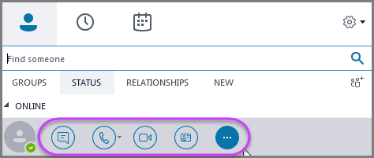
Option 1 – Using symbols or icons

Option 2 – Pull down text menu of options.

Option 1. To contact others, hover over a person’s face or placeholder in your contacts and determine how you would like to reach out to them. There are several methods to contact them, which are displayed as a symbol or icon. By clicking on an icon, a pop-up box using that method is ready to begin.
Option 2. If you would rather see the action in text rather than a symbol, right click over their title and a drop-down menu appears. There are several actions you can perform by clicking on the option you wish.
If you would like to add others to the conversation, left click on their contact and drag them into the conversation.

Creating On-line Meetings

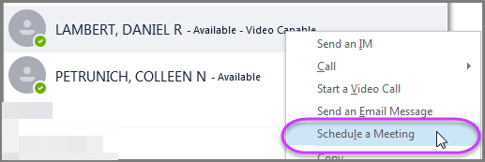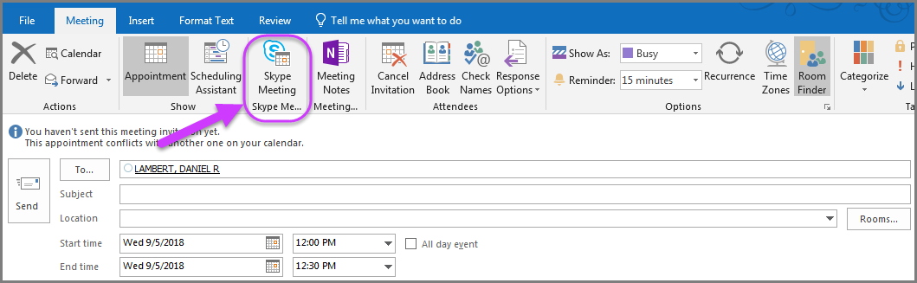
On line meetings are created just like Outlook calendar. Right click on a person’s name for a drop-down menu and click on “Schedule a Meeting” When the second pop up screen is displayed, it will have the person’s name and dates. You can add names or change the time/location. Click on Skype Meeting” to add a link to the invitation (see below). The recipient will click on the Skype meeting link to join the meeting. Click “Send”. Once you’re in a meeting, click for further options such as recording.
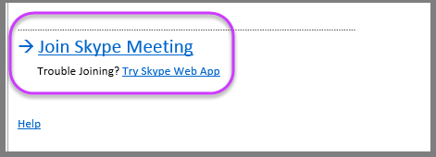

Searching for another Employee (or external client)

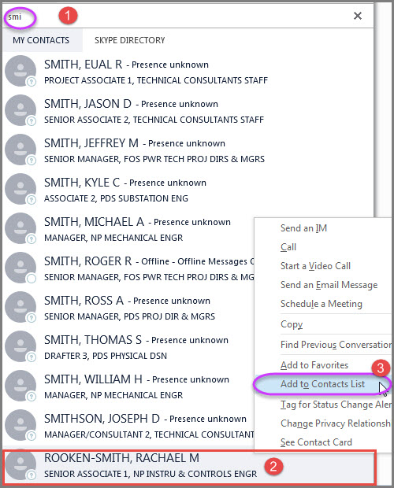
Searching for Employees
In the text box which has “Find Someone” begin typing in last name. The software recognizes the text and tries to “match” it. This is called predictive text. The more you type the narrower the search.
In the example to the left, you can see by beginning to type “Smith” there are several returns even though names may have variations of “Smith”.
QUICK! Once you found the correct name, if you double click on your selection, an instant chat box is opened and ready to send.
If you would like to “save” the name for faster searching in the future, you can save it by right clicking on the name. When the drop box is displayed, click on the “Add to Contacts” List.
You can see by the graphic several choices are available such as “Start an Email” or a “Video Call”.

Conversation History

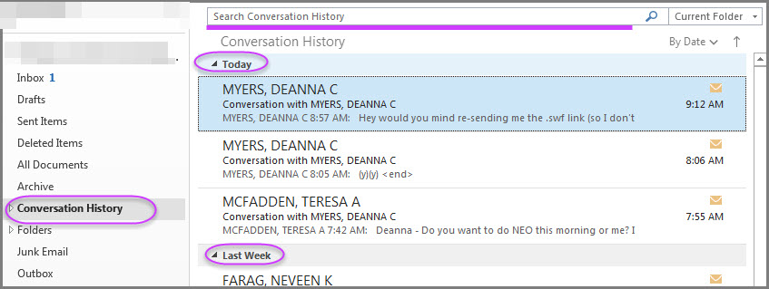
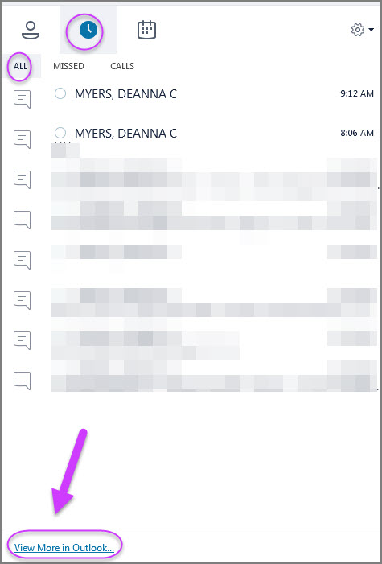
You may check the conversation history in both Skype and in Outlook. You can delete conversations from either location. Additionally, you may search for specific topics/words in a conversation, a date or by person by using the “Search Conversation History” in Outlook.
(Skype)
(Outlook)

Personal Settings

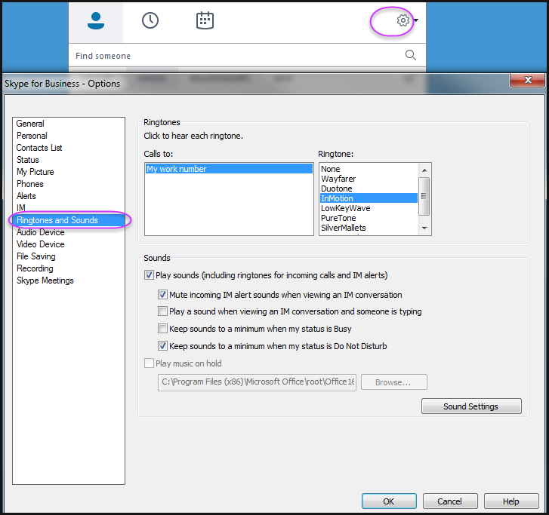
Personal Settings
Like most software today, there are areas where you can customize items for individual preferences.
Click on the gear icon shown on the top right-hand side of the Skype box.
Scroll through the options to see the choices available. In this example, the ringtone and sounds are available to change for incoming messages or for phone messages. Once you have made changes, be sure to click the “ok” button to keep the changes.

