[Date]
September 07, 2018
Outlook Email 2018
Basics with Tips and Tricks

Table of Contents

Basics: Opening Outlook 2
To Open Your Outlook 2
From Desktop 2
Setting Up Outlook 3
Navigation Pane 3
Identifying Your Email Home Page 4
Create a Signature to Messages 7
Check Your Outlook at Home Computer (or Phone) 9
“Tell Me What You Want Me to Do” Query 9
Creating Groups 11
Tips and Tricks 12
Turn a Message into a Meeting 12
Change Color by Incoming Mail 14
Rescinding (Recalling) Email 15

For further help, please contact the help desk. 312-269-3590 or send an email to Helpdesk@sargentlundy.com

Basics: Opening Outlook

To Open Your Outlook

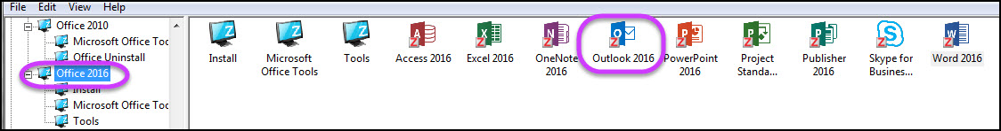
In your Novell applications, select Office 2016. If you have not set up your Office 2016 at this point, you must do this first. Then, left click once on the “Outlook” icon and drag it onto your desktop. From now on, you may access your email/calendar from your desktop
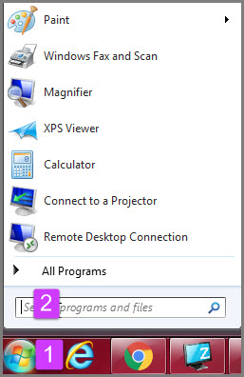

From Desktop
- From the menu options on the bottom of your monitor screen, click on the MS “world icon”
- In the blank text box field, type in Outlook and the enter key.

OR

Setting Up Outlook

Navigation Pane

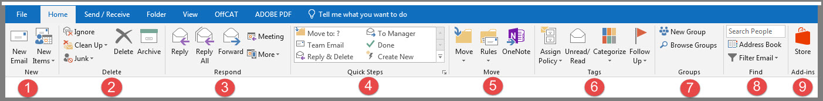

New: New Email /New Items. Click on “new Email to begin a new email.
- Delete: Ignore, Clean Up, Junk, Delete X and Archive. Advanced Options.
- Respond: Reply, Reply All and Forward. These tasks are the same as any email application. Meeting and More.
- Quick Steps: Advanced Option
- More: Advanced Option
- Tags: Advanced Option
- Groups: Start a new “Group” or use “Browse Groups” already in existence. If you want to join, request to join.
- Find: Address Book. Use the “Search People text box” to find an email either sent or received by a specific person. Filter Email is a filtering method which searches through your email to find a subject/word or by date.
- Add-ins: Advanced Option.

Identifying Your Email Home Page

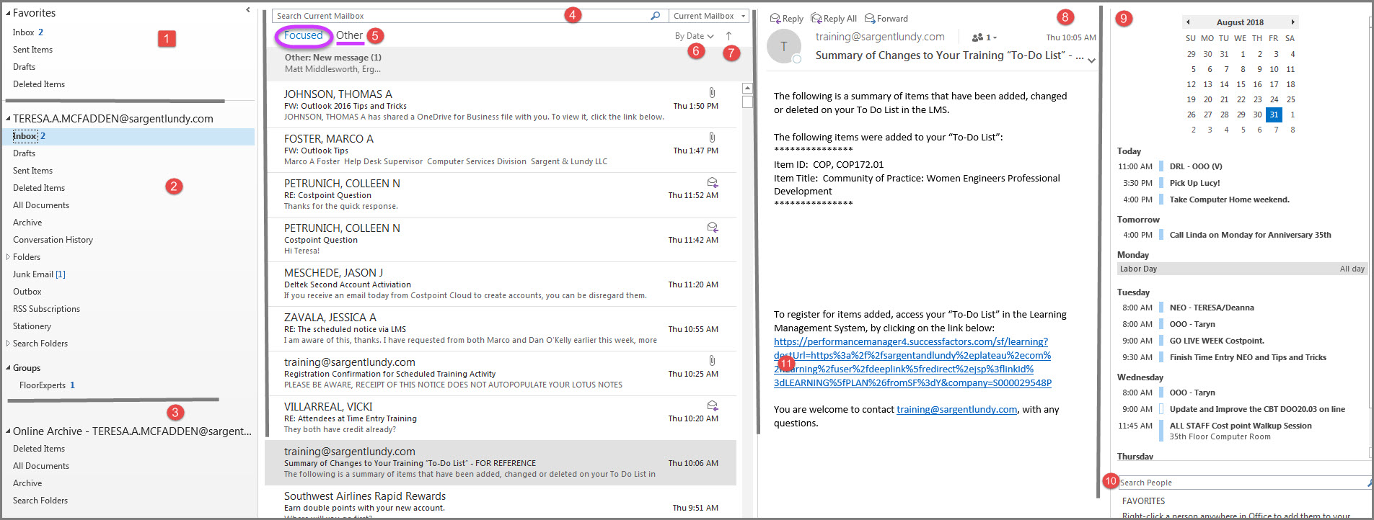

Favorites. Your favorite emails are stored here. You can remove this box if desired.
- Inbox. The inbox will have the number of items which are not opened in blue. Corresponding mails with the subject line and the date/time received are shown in blue, indicating they have not been opened yet.
- Archive. This is your archive items and deleted items.
- Search Current Mailbox. A search by word filters emails. You may enter a name or an email address or date.
- Focused/Other. The focused are emails with recognized credentials, whereas the “Other” may be junk mail or spam.
- Sort by Date. When you click on the “By Date” arrow, there is a drop-down menu of filtering items.
- Sort Up Arrow. By clicking on the arrow, the inbox sorts either with the most recent on top or most recent on bottom.
- Reading Pane. Whatever email is highlighted will automatically show in this section. If you wish to open the email double-click on the email and it will open in an expanded view.
- Calendar preview. You may quickly get an idea of what is on your calendar. If you wish to jump directly to that day in the calendar, click on the calendar day (of the month) or the horizontal time for further information in your calendar view.
- Search People. You may type in a name, when a match is displayed, right click on it, to add to your contacts or favorites. This will also have their title, department, phone and location. By clicking on the envelop icon, an email with the recipient’s address is ready for you.
NOTE: All incoming (unopened) emails have the subject and the date displayed in blue ink (see below).
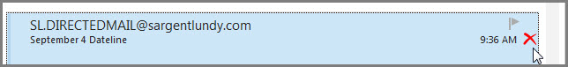
Customizing Your Home Page
The “Reading Pane” arranges the format of Outlook’s home page. For example, instead of vertical columns as in the default, you could select vertical columns if you would like to read your email using this format.
The To-Do Bar pull down menu is defaulted having all the options checked. If you would like your email to not have a calendar, people or task, click on “Off”,
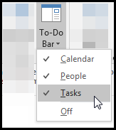
“People Pane” pull down menu options are Normal, Maximized, or “Off”. The “People Pane” may be sorted by ALL, Mail, Attachments and Meetings. For example, if you select a person, and select “attachment” all attachments from that person is displayed! If you select “Mail” emails and Instant Messaging with Skype will be displayed. This feature is great for researching conversations or meetings with that person.

On the “View” tab, see the Layout and People Pane (circled in purple). Each option has a down arrow for an expanded menu.
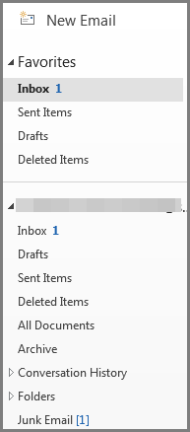
The Folder Pane the first column which displays various folders such as Inbox, Draft, Sent Items, Deleted Items, Archive, etc. You may minimize or remove this column if you like to. You may also remove the “favorites” section from this option.

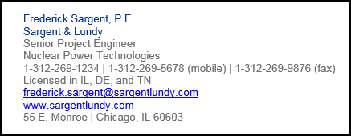
Create a Signature to Messages
Example:

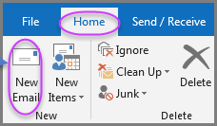

A signature or a sender’s information can be customized. To create your signature, go to the “Home” tab in the Email Navigation pane, click on “New Email”. Then, click on the “Signature” down arrow for pop-up box. Fill in your information. Click “OK” when completed.

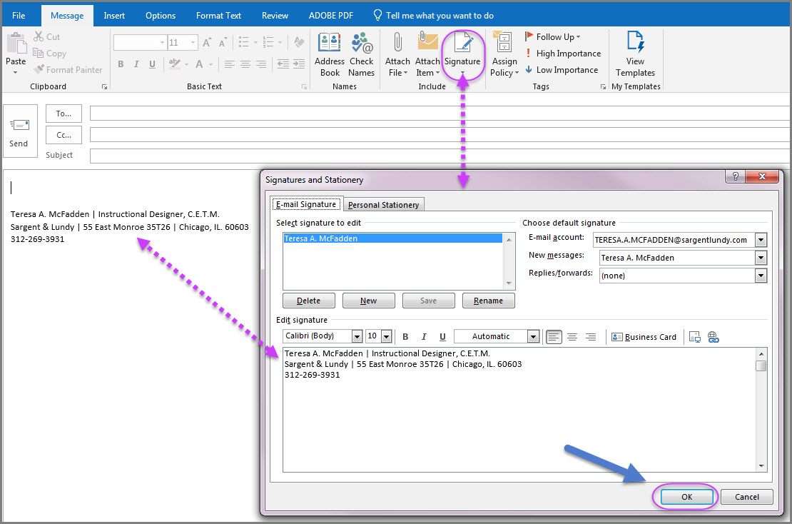

Deleting Emails/Deleted Folder
Deleted Items
When you wish to delete items in your Outlook email, you have several choices:
- Delete either before or after having read the email by clicking on the “X” next to the time stamp (the email arrived in your email box). If you move your mouse to the time location the “X” will appear black, however, once you are directly on top of the “X”, it will turn red. These emails will drop into your deleted folder (see circled graphic on the left). By double clicking on the deleted items folder, all previously deleted items which were sent to your delete folder will be displayed. At this time, you may recover Email, or you can click the red X again which will permanently delete the Email, or you can restore them at this time (below shown in blue print).
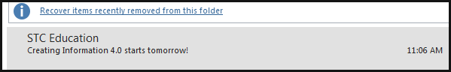
- To permanently rid your emails from the deleted folder, right click on the “Deleted Items” folder. When the drop-down menu is displayed, click on, “Empty Folder” and click “Yes” for permanently delete.

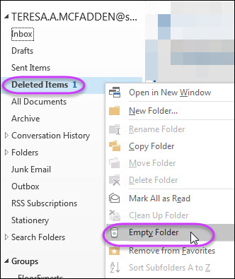

Note: You may also select to permanently delete the email BEFORE it is sent to the
“Deleted” folder. Clicking on the email and hold the shift key then click on the “Delete” button on your keyboard.

Check Your Outlook at Home Computer (or Phone)

Outlook application is cloud-based so you can check your communications from anywhere! Use the address below:
https://login.microsoftonline.com

“Tell Me What You Want Me to Do” Query

This feature allows you to type a subject or word in the text area (shown circled) if you are looking for a specific feature. The software has predictive text, therefore it will “try” to find matches. Pop up menu with similar matches will appear as drop downs. If you type in the word and click the “Enter” key the actual pop up box with the corresponding feature will be displayed. Below are some examples.
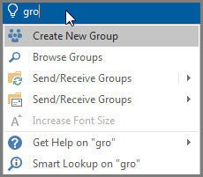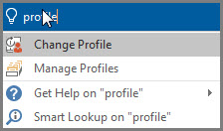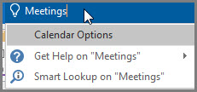

Automatic Replies – Out of Office
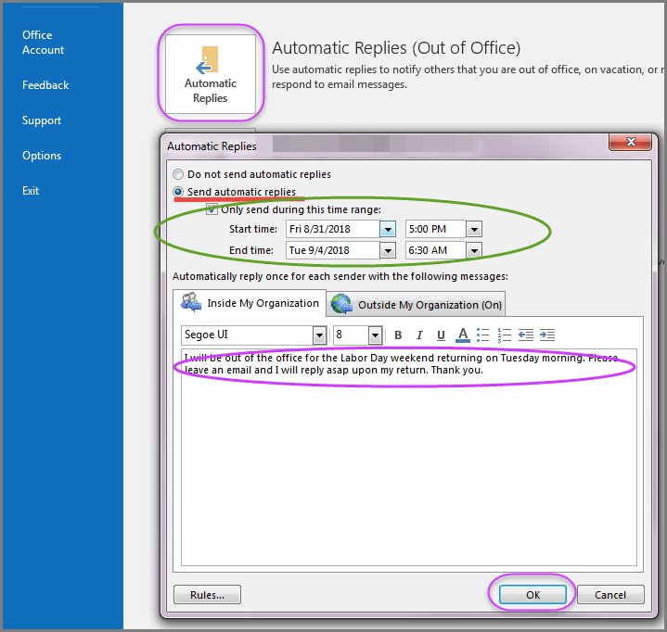
- Go to mail and click “File” from the Navigation Pane. The blue-ribbon side bar will appear with several options to the right of it
- Click “Automatic Replies”.
- Make the selections shown above (Auto reply, click “Only send during this time range” and set the dates and time range
- Create a short message and preferable how the person may get in touch with you. Click the “OK” button.

Creating Groups
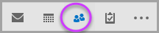
If you send emails to the same group of people, save time and effort by creating a custom contact group. Open Outlook and click on the people/contacts icon on the bottom left hand side of the Navigation pane.
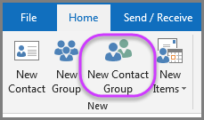

From the Home tab, click on “New Contact Group”
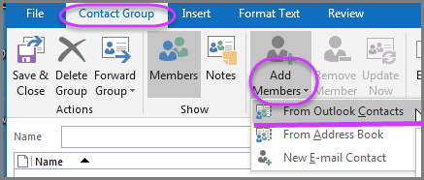
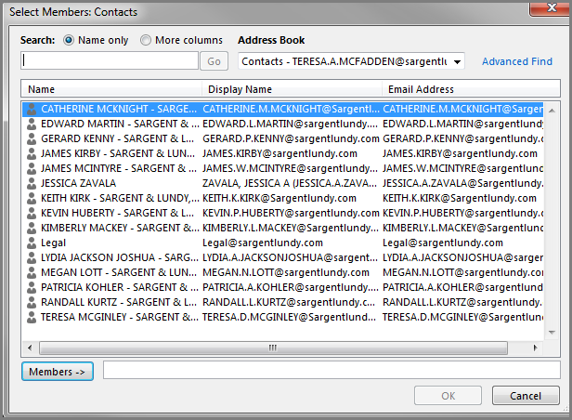
With the “Contact Group” tab applied, click on the “Add Members” which will have a drop-down menu. Select “From Outlook Contacts”. Your contacts will appear. Hold the CTRL key as you select each email contact you want to add to the group. Click the members button to add those contacts as your group members and then click “Ok”. Enter a name for the group.

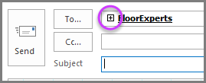
When you want to send an email to the group, begin a new email, type the name of the group in the “To” box. If you wish to see the members, click on the + box to the left of the group name. This will expand the persons in the group. Be sure to keep the group contact list updated and current.
To Edit Group: Go to contacts, click on the group name, then click Edit to add or remove contacts from the group.

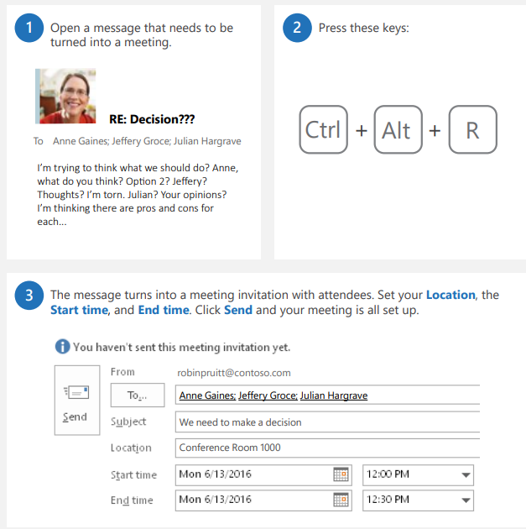
Tips and Tricks

Turn a Message into a Meeting

Steps:
- Open the email which contains the conversation and the persons.
- Click CTRL, ALT, R at the same time.
- Outlook will “identify” the person(s) involved and set up a meeting invite.
- Tweak the time and date if needed. Click the Send button.
NOTE: the body of the email will be included in the invite.

Change Incoming Message by Color or Fonts
Conditional formatting is a way to display messages stand out by color or font/styles. By specifying conditions what incoming messages by sender name or email addresses, the conditional format is then applied.
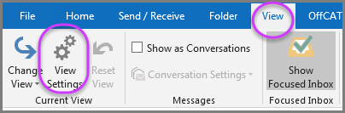
On the Navigation Pane, select “View” tab. In the “Current View” group section, click on the “View Settings” tab. From the pop-up menu, click “Conditional Formatting”
In this setting, all the checked conditions are met for the font to be 11 pt. Segoe UI in blue. Click on Font button to see the font conditions.
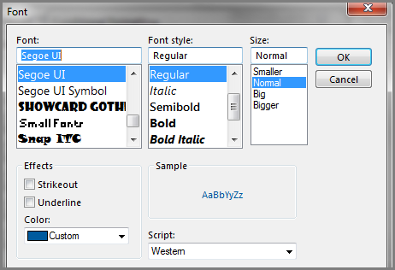
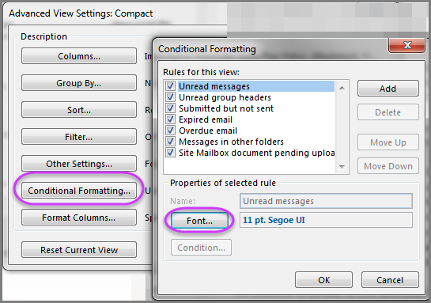

Change Color by Incoming Mail
Incoming Mail from John Smith
- Click the “Add” button
- Enter Name in the name text box
- Click the font button, Select a color and/or font style
- Click “Condition” button
- In the “From text box type in the name (exactly) or use the “From button which gives the exact listing in the S&L Global Directory
- Click “OK”

You can filter by Word in the subject or message body and set font color or style as a perimeter for the word.

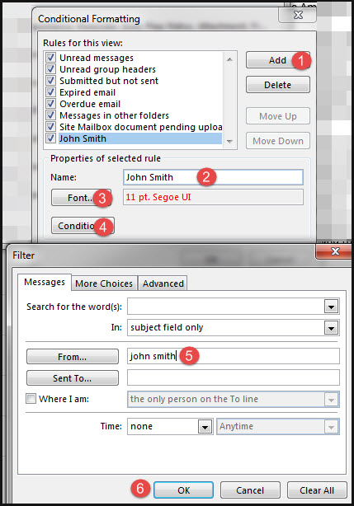

Rescinding (Recalling) Email

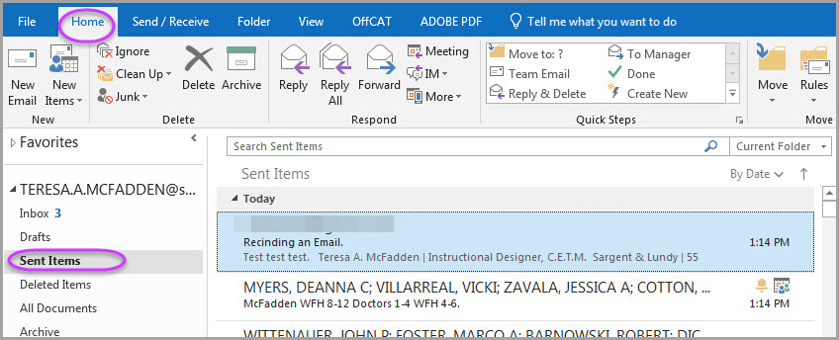
Double Click the Sent Email to Open
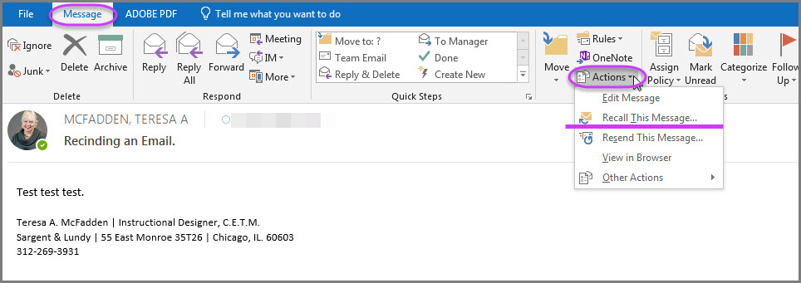
After you send an email you decide to recall the message you may do, if the receiver has not opened it. From the “Sent” folder, open the email in full that you wish to recall by double clicking on it. Now click on the “Message” tab, the “Actions” down arrow and finally the “Recall This Message” option.

