8/1/2018
September 07, 2018

office-training.sargentlundy.com
On-Line Video Tutorials by Microsoft

Outlook Calendar
Basics with Tips and Tricks
Contents
Basics 2
Switching from Outlook Email to Calendar 2
Reading the Calendar Navigation Pane - Home Tab 3
Setting Up Your Calendar 4
Change Calendar from “Day” View to “List” View 5
Adding and Viewing Another Person’s Calendar 6
Creating a Meeting Invite 7
Create a Recurring Meeting 9
Finding Available Rooms 10
Using the Search Feature 13
Check Other’s Availability 14
Working Offline 15
“Tell Me What You Want Me to Do” Query 16
Individualize Your Settings 17

For further help, please contact the help desk. 312-269-3590 or send an email to Helpdesk@sargentlundy.com

Basics

Switching from Outlook Email to Calendar
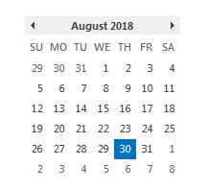
NOTE: You may also “click” any day on the calendar in your email and the software will jump to the calendar.
On the bottom left hand side of your email, notice four symbols which are tabs to move to another screen.
- Email symbol – Your email in Outlook
- Calendar symbol – Your calendar
- People symbol – Your contacts
- To Do List – or Tasks - Calendar schedules which have been schedules are listed vertically.
NOTE: Whichever symbol is highlighted a color (not grey in this example, blue) is what application you are currently located. To switch locations, click on the other symbol. Shortcut keys are:

Takes you to your email Takes you to your Calendar Takes you to People Takes you to tasks

Reading the Calendar Navigation Pane - Home Tab
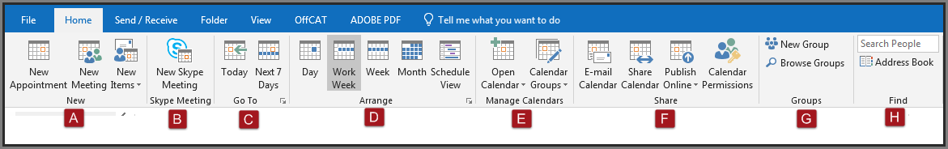
- New. New Appointment, New Meeting and New Items. New Appointment and New Meeting are the same except the Meeting has a text box for adding people. New Items is the best selection as it provides a drop down menu to select the task you would like to perform including Skype Meeting.
- Skype Meeting.
- Go To. Switches the view from the present day calendar to the next 7 day calendar
- Arrange:
  - Day, Work Week, Week, Month,. Each of these options displays the calendar to what you select.
  - Schedule View - Use this view for multiple calendars. Click to open, then add Calendar(s) desired or if they are already available, just click on it. Each person selected caledar is viewable on each horizontal line making their availablity clear. Where you find an open slot available, double click on it to open the “invite” address window. Begin typing in the text bar, predictivie text will display like options. Now double click and press “select” to populate the name (s) into the text bar. There is a required, option or resources horizontial line. For further information on this task, see the job aid section “How to Create a Meeting Invite.”
- Manage Calendars. One is for your personal calenda which has a drop down menu of where to get the calendar from and the other option is for group calendars either creating or adding a new one.
- Share. The Share calendar can be sent via email to any one after specific criteria is set. For example, what date range, what hourly time range, etc. The information is compliled and sent via email to a receipicent.
- Groups. Browse an existing group or create a new group for a workspace to share email, documents or calendars.
- Find. This is where you can find information such as workgroup, job level, department, real time skype availablity (has a direct link to send an instant message via Skype) blocked time in their calendar, mail groups they are part of, phone number and photo if added.

Setting Up Your Calendar
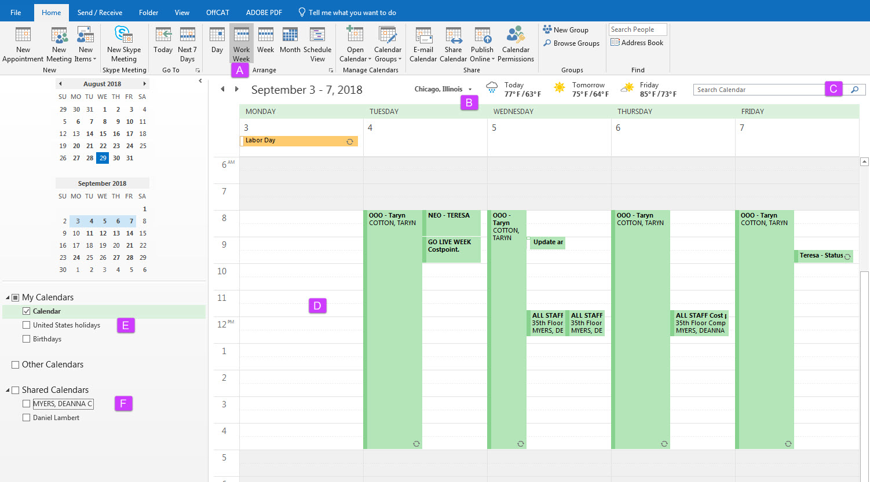
- Set tabs up for days you would like. Shown in this display is a 5-day calendar for “Work Week”
- Set the location (city/state) to have the weather and time zone displayed.
- Search calendar using topic or date
- Calendar is set for 8:00-5:00 for a normal workday. The greyed-out area is shown for out of normal work hours
- Check boxes if you would like to see separate calendars such as birthdays or holidays
- Shared Calendars – depending upon how the owner has set their viewing levels. Example is blocked times or detailed information.

Change Calendar from “Day” View to “List” View
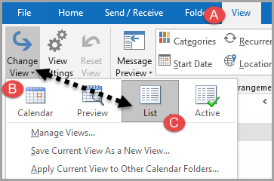
- Click on the “View” tab on the Navigation pane.
- Click on the “Change View” arrow option. This will provide another pop up box.
- Select “List” from the options. All of your calendar entries are shown in a list order. You may sort ascending or decending by clicking on the arrow by the “Start” date (shown circled in purple). Note: this function can also be performed in the email version of Outlook for reformating the format layout.
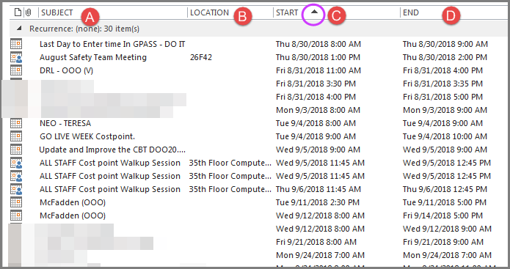

Adding and Viewing Another Person’s Calendar
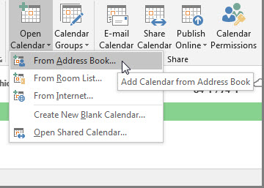
On the Navigation Pane, the “Home” tab is open. From the “open calendar pull-down arrow, click on “From Address Book”. 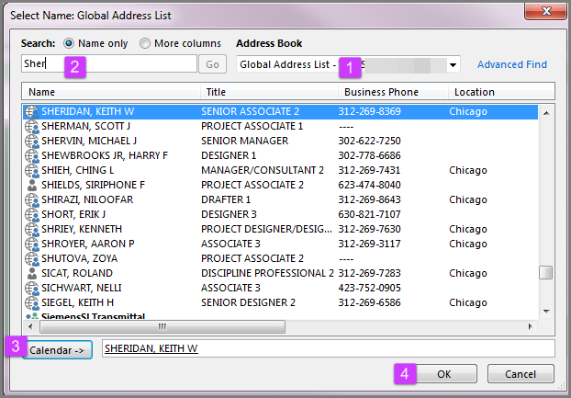
- Select from the drop-down arrow “Global Address List”
- Begin typing in the last name. Predictive text will pull up similar matches. The more information entered, the narrower the results.
- Click on Calendar to populate the contact’s name.
- Click “OK”

Creating a Meeting Invite
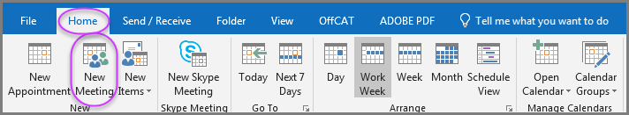
To create a new meeting, select the “Home” tab and then click on “New Meeting”. The invitation below is displayed.
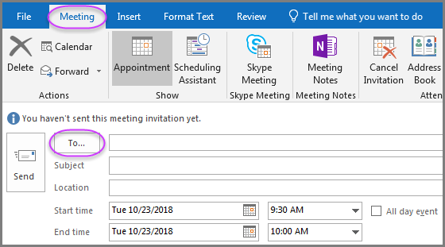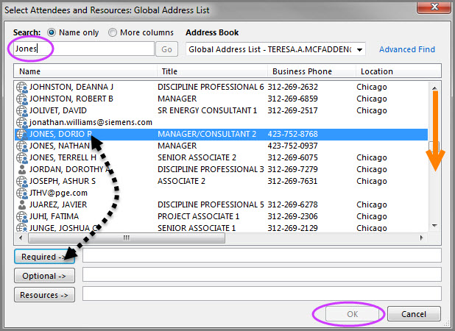
Your cursor defaults at the “TO” box. Click. A pop-up box of options is displayed (graphic shown on right). Set the Address book to “Global Address List” Either scroll alphabetically (see orange arrow in graphic) or type the last name in the search field. Click with your mouse on the name which will highlight the selection (shown in blue). Click the “Required” box, which will auto populate. Now click the “OK” button.
NOTE: If you have used the name before, you may begin typing the person’s name in the “TO” text box (predictive text), then click on the name and it will automatically pop into the “To” text box. Continued next page.

Creating a Meeting Invite, continued.
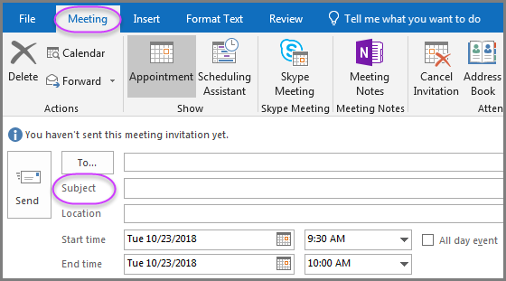
Continue to fill in the text box for Subject” line. For the Location, if a room or description has been entered previously, use the down arrow in the Location text box for a drop-down selection. If never used before, click the “rooms” to the right side. Shown below to the right of the page by the “Location” text box. The rooms will be listed in numerical order. 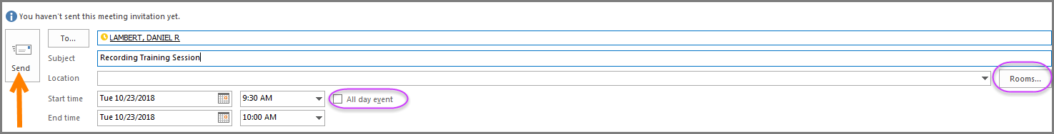
Now click the “Send” (orange arrow) button. If this is an all-day event, click inside the box next to “All day event” which will block the whole work day. Completed.

Create a Recurring Meeting

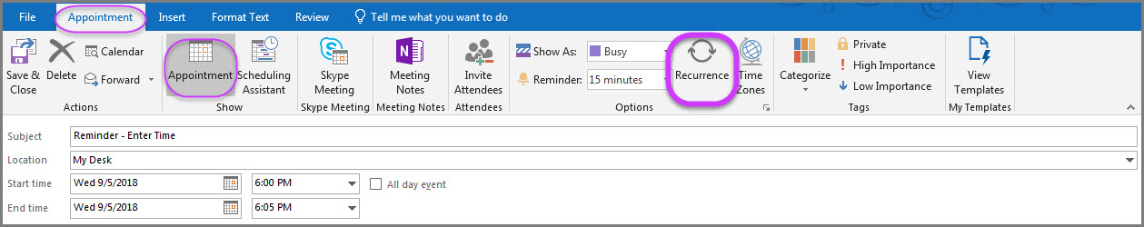
Recurrence
You can create a meeting or a reminder which is repeated either daily, weekly, monthly or yearly. To do this, double click in the space of the beginning date and time in the series on your calendar. You will now see the appointment menu pop up (see graphic). Fill in the subject, location, start time and end time.
Now click on the recurrence icon shown circled in the graphic. Another pop-up menu will be displayed. Set the criteria you would like and click “Ok”.
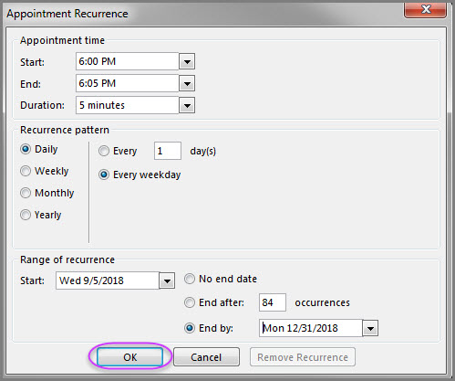

Finding Available Rooms

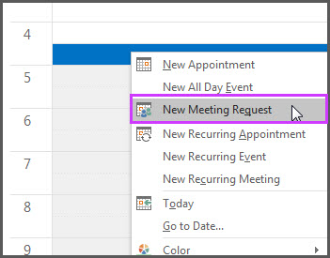
Go to the Outlook calendar preferably on the date and time you would like to schedule a meeting. Right click your mouse to “New Meeting Request”.

Continued next page.
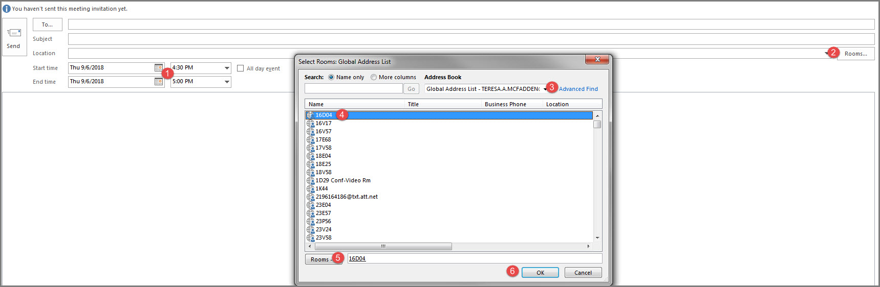
- Check the date and time to be sure that is when you would like the room.
- Click on “Rooms” button to the right of “location” A new pop-up box will be displayed.
- Check the Address Book is set to “Global Address List”
- Click the room desired (or you may select multiple rooms to check availability by using the ctrl key, see example on next page). Your selections will then populate into the “To” and the “Location” text box.
- Click on “Rooms” button, which will populate the room(s) into the text box.
- Click “OK”.
- Add persons invited and add the subject in the header of the email.
Continued next page.
Reserving rooms continued.
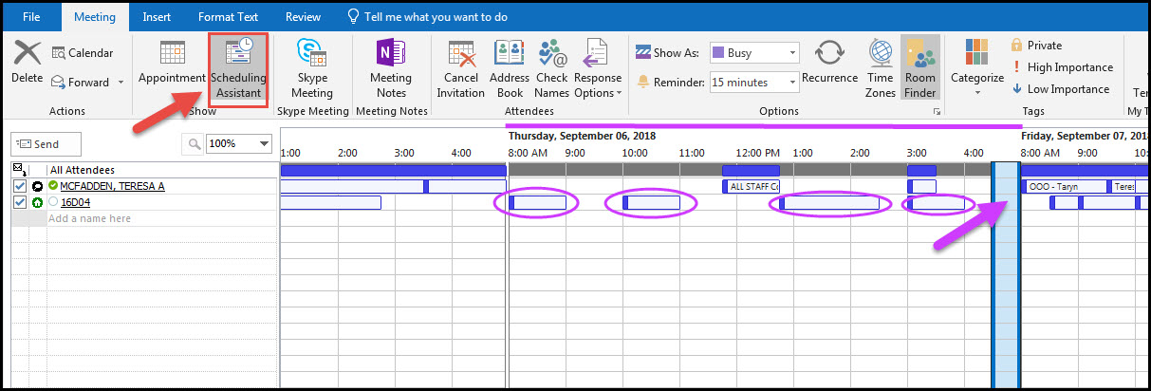
Click on the “Scheduling Assistant” (red arrow) to see a graphic view of the day you are scheduling. As you can see the room and attendees are both open at 4:00 on Thursday. The room is blocked on the circled days and open where there is no blue box on the cell.
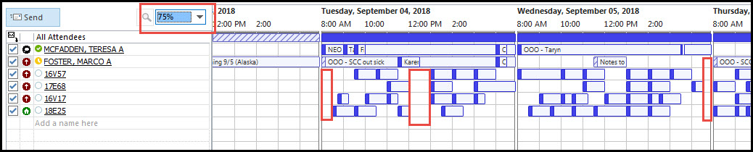
If you change the % percentage viewable, the range of details increases or decreases. In the above example, the red boxes indicate when the rooms and the invitees are available. NOTE: This feature will improve once all employees schedules have been migrated.

Using the Search Feature
To find a meeting in the Outlook Calendar using the word search option, place your cursor in the “Search Text Box” on the home page and begin typing in a word. All meetings or appointments which include that word either in the title or subject line, will be displayed in linear format.
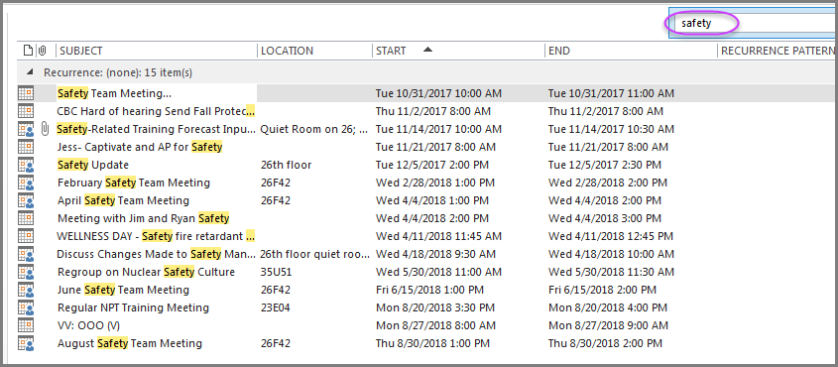
On the Navigation pane under “Search” tab, click the “Close Search” X icon under “Close” category. 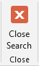 .

Check Other’s Availability
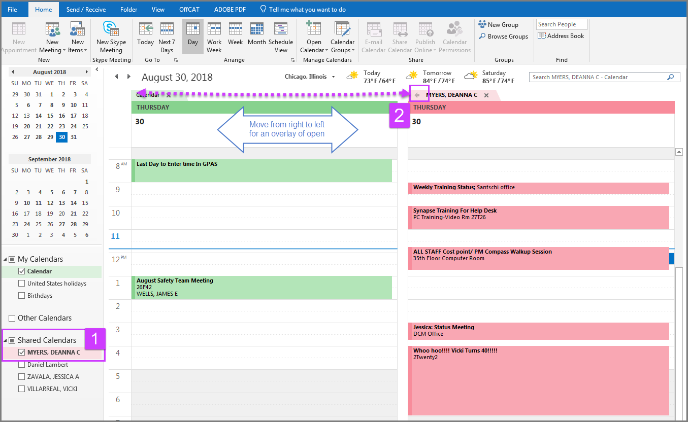
- Add contacts to Calendar (see page 3) and check the box in the “Shared Calendar” of the person’s calendar
- On the left side of the person’s calendar name there is a left arrow. Move the whole calendar on top of yours. You will see the open opportunities for a meeting.

Working Offline

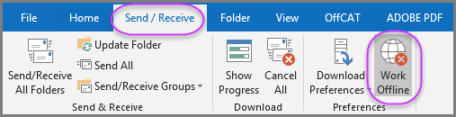
In both the calendar and the email, outlook allows you to work within the software without being on-line. In the navigation pane, under the Send/Receive tab, select the world icon “Work Offline” under the “Preferences” section.
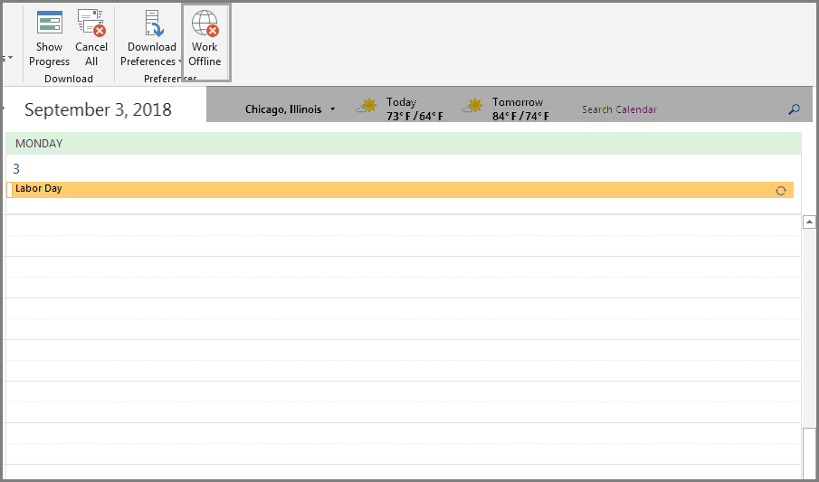
You will be able to distinguish between on line and off line by the Work Office Offline icon is greyed out and the temperature and location information is removed and the “word search” text box is in its place.

“Tell Me What You Want Me to Do” Query

This feature allows you to type a subject or word in the text area (shown circled) if you are looking for a specific feature. The software has predictive text, therefore it will “try” to find matches. Pop up menu with similar matches will appear as drop downs. If you type in the word and click the “Enter” key the actual pop up box with the corresponding feature will be displayed. Below are some examples.
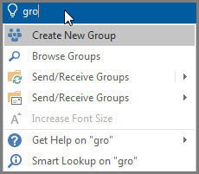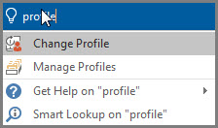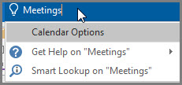

Individualize Your Settings
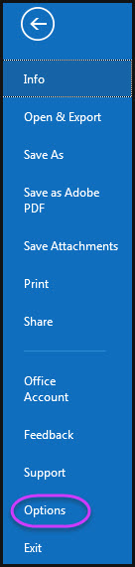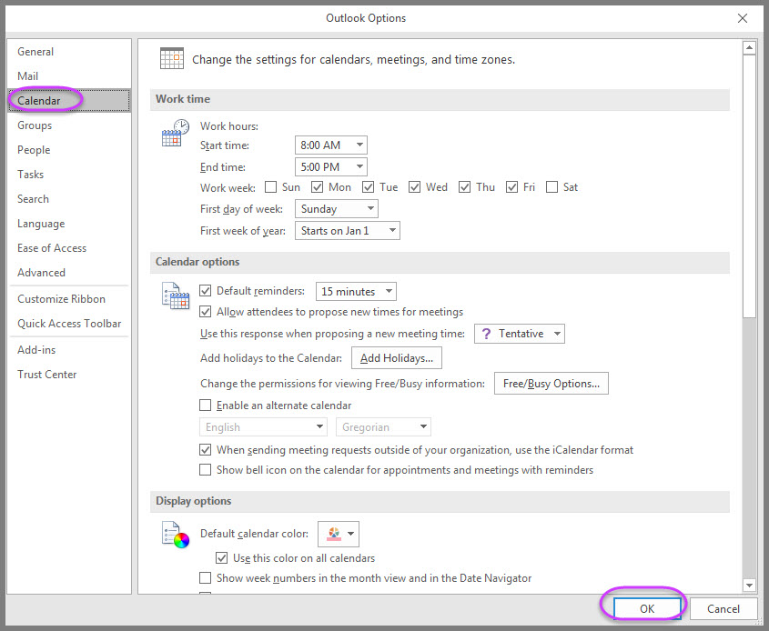
Click on File tab on the Navigation pane. From the blue border, scroll to “options” and a pop-up menu will be displayed. Switch the default from General to Calendar (second graphic) as shown. Make any changes you would like such as the work hours start time or default reminders timing, or individual holidays observed. Then click “OK”.

